PCA - Cereals case
Data were collected on the nutritional information and consumer rating of 77 breakfast cereals.

Let’s have a look at correlation of pairwise variables. calories and consumer rating. Using R, the output show that

cor(cereals$Calories,cereals$Rating)
-0.689376

The interpretation: 69% of the total variation in both variables is actually “covariation,” or variation in one variable that is duplicated by similar variation in the other variable.

Mean and variance

 | calories | consumer rating | Total
Mean | 106.88 | 42.67
Variance | 379.63 | 197.32 | 577

Question: Can we use this fact to reduce the number of variables, while making maximum use of their unique contributions to the overall variation?

Solution: Since there is redundancy in the information that the two variables contain, it might be possible to reduce the two variables to a single variable without losing too much information.

->
The idea in PCA is to find a linear combination of the two variables that contains most, even if not all, of the information, so that this new variable can replace the two original variables.

Issue: Information here is in the sense of variability -> What can explain the most variability among the 77 cereals.

Solution 1: The total variability here is the sum of the variances of the two variables, which in this case is 379.63 + 197.32 = 577. This means that calories accounts for 66% (= 379.63 / 577) of the total variability, and rating for the remaining 34%. If we drop one of the variables for the sake of dimension reduction, we lose at least 34% of the total variability.

Solution 2: Can we redistribute the total variability between two new variables in a more polarized way? If so, it might be possible to keep only the one new variable that (hopefully) accounts for a large portion of the total variation.

Method to implement solution 2:

First let plot these variables on 2-dimensional space:

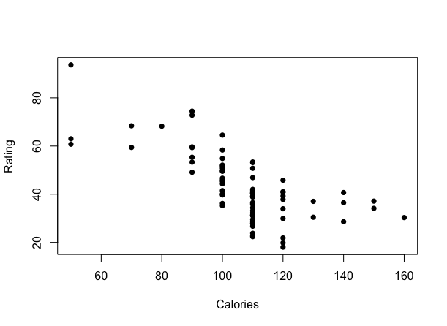
Let’s say we plot z1 line as the direction in which the variability of the points is largest. It is the line that captures the most variation in the data if we decide to reduce the dimensionality of the data from two to one. Among all possible lines, it is the line for which, if we project the points in the dataset orthogonally to get a set of 77 (one-dimensional) values, the variance of the z1 values will be maximum. This is called the first principal component. It is also the line that minimizes the sum-of squared perpendicular distances from the line.
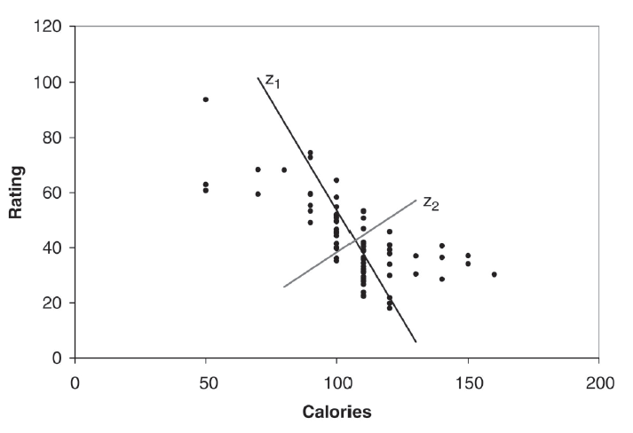

The z2-axis is chosen to be perpendicular to the z1-axis. In the case of two variables, there is only one line that is perpendicular to z1, and it has the second largest variability, but its information is uncorrelated with z1. This is called the second principal component.

PCA in R results:

#first component: calories, sugars, rating, and fat
#second component: Potassium, Fiber, and protein #health conciousness
#third component: carbo, qaker
#fourth component: cold and AHFP
#fifth component:Kellogss
#12 variables | 20 variables
#65% | 100% of total variance

